**RF Transmitter Receiver Module using Arduino**

Introduction

Wireless Communication in any form has become an essential part of human life whether it may be short distance T.V Remote or long distance radio communication. Wireless communication is all about transmission of data wirelessly so that there is no hassle of any wires and no direct contact with the device itself.

In this project, the transmitter simply sends two characters i.e. it sends the character “1” and with a delay of few seconds, it sends the character “0”. Whenever the “1” is sent, the LED on the transmitting side of the project will be turned ON. As this “1” is transmitted via RF communication, the receiver will receive the data “1”.

When the receiver receives “1”, the Arduino on the receiver side of the project will turn ON the LED on its side.

Similarly, when the data “0” is transmitted by the RF transmitter, the LED on the transmitter side is turned OFF. As a result, the receiver now receives “0” and the LED on the receiver side is also turned OFF.

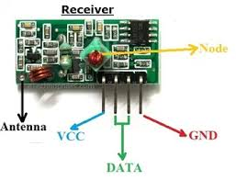

**Components**

* Arduino UNO 2
* 434 MHz Transmitter Module (or 315 MHz Module)
* 434 MHz Receiver Module (or 315 MHz Module)
* 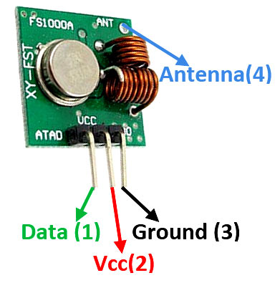LED  2
* 1 KΩ Resistor 2
* bread board
* Connecting wires
* Power supply (Adapter or battery)

**Application**

* + RC Cars
  + Home Automation
  + Robotics

**Objective**

**During This activity ,you will help students to achieve following objectives**

**1.** Understanding the principle and operation of transmitter & receiver

2. Design algorithm and flowchart for how digital signal is sent

3. Programming 434 MHz Transmitter & Receiver Module using Arduino uno

4. Interfacing 434 MHz Transmitter & Receiver Module with Arduino uno

**Programming steps**

1. Include library virtual wire for RFmodule(https://www.pjrc.com/teensy/td_libs_VirtualWire.html)
2. Initialise led pin as output for transmitter and receiver part
3. Send data towards receiver using tx pin
4. When recever receves data,display it to serial monitor

**Program**

**Transmitter code**

#include <VirtualWire.h>

const int ledPin = 9;

char *data;

void setup()

{

pinMode(ledPin,OUTPUT);

vw_set_ptt_inverted(true);

vw_set_tx_pin(12);

vw_setup(4000);

}

void loop()

{

data="1";

vw_send((uint8_t *)data, strlen(data));

vw_wait_tx();

digitalWrite(ledPin,HIGH);

delay(2000);

data="0";

vw_send((uint8_t *)data, strlen(data));

vw_wait_tx();

digitalWrite(ledPin,LOW);

delay(2000);

}

**Receiver code:**

#include <VirtualWire.h>

const int ledPin = 9;

const int datain = 12;

void setup()

{

vw_set_ptt_inverted(true);

vw_set_rx_pin(datain);

vw_setup(2000);

pinMode(ledPin, OUTPUT);

vw_rx_start();

}

void loop()

{

uint8_t buf[VW_MAX_MESSAGE_LEN];

uint8_t buflen = VW_MAX_MESSAGE_LEN;

if (vw_get_message(buf, &buflen))

{

if(buf[0]=='1')

{

digitalWrite(ledPin,HIGH);

}

if(buf[0]=='0')

{

digitalWrite(ledPin,LOW);

}

}

}

**Hardware**

**1.** The RF Transmitter Module consists of 4 – pins: VCC, GND, Data and Antenna. VCC and GND pins are connected to 5V and ground respectively. The data pin is connected to any of the digital input / output pin of Arduino. Here, it is connected to Pin 12.

**2.** The antenna pin must be connected to an antenna which is nothing but a wire wound in the form of a coil.

**3.** The RF Receiver Module consists of 4 – pins: VCC, GND, Data and Antenna. VCC and GND pins are connected to 3.3V pin of the Arduino and ground respectively. The data pin is connected to Pin 12 of the Arduino.

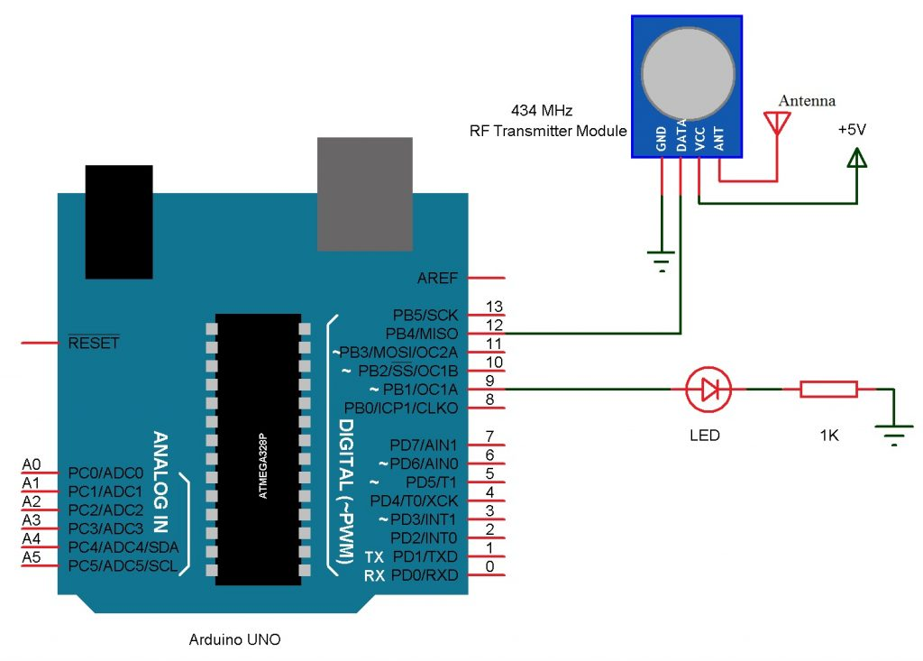

Receiver part

